INTRODUCTION

For this part of the assignment, Our goal is to get our model to achieve a prediction accuracy of 75% or higher, with three attempts. We can use any method that we have learn in class to help optimize our model.

**ATTEMPT #1**

On my first attempt I decided to drop two additional columns from the starter code. The two columns that I chose were Organization and Use Case.

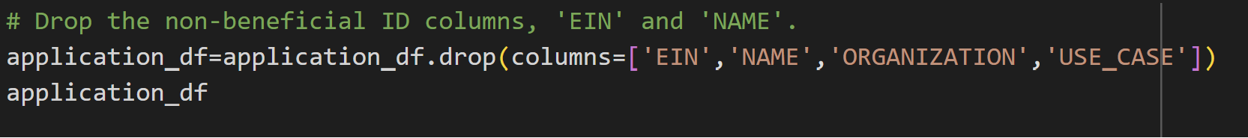

I also decided to change the node layers, the first layer equal to 4 and the second layer equal to 5. After running the model, my model predictions accuracy was lower than the first time we ran our model. The accuracy was at a 71% compare to a 72%

**ATTEMPT #2**

For the second attempt I decided to only drop the first two columns from when we started our original starter code. From there I decided to change the number of inputs of the hidden and I set them both at 20. The third step I decided to change as well is the activation features and have both first and second hidden layer set at “tanh”.

After making these changes and making changes to the number of epochs set at 20 our model was able to have prediction accuracy at a 72.5%. The second attempt improve somewhat better than our first attempt.

figure 2: second attempt

figure 3: model accuracy for second attempt

**ATTEMPT #3**

For my third attempt I decided to drop only 3 columns, ‘NAME’, ‘EIN’, AND ‘STATUS’. I also change the number of hidden nodes to 15 for the first layer and1 5 for the second layer. The functions were all change ‘relu’ for the first layer, ‘sigmoid’ for the second layer, and ‘sigmoid' for the output layer. After running the model, our accuracy prediction was at a .72501%

